Missing Video Issue – Troubleshooting Document

scenario 1 - If a video is missing on the front end or is not playing properly.
scenario 2 - where video is not present in both video clipper and substory
scenario 3- where wrong substory is processed in front end and video is not present in bucket.
scenario 4 - where video is showing missing on front end but after opening qc form video is playing in that case video can be reprocessed.

scenario 1 - If a video is missing on the front end or is not playing properly, follow the steps below.

Step 1: Check Video in GCP Bucket
First, verify whether the video is present in the QA bucket.
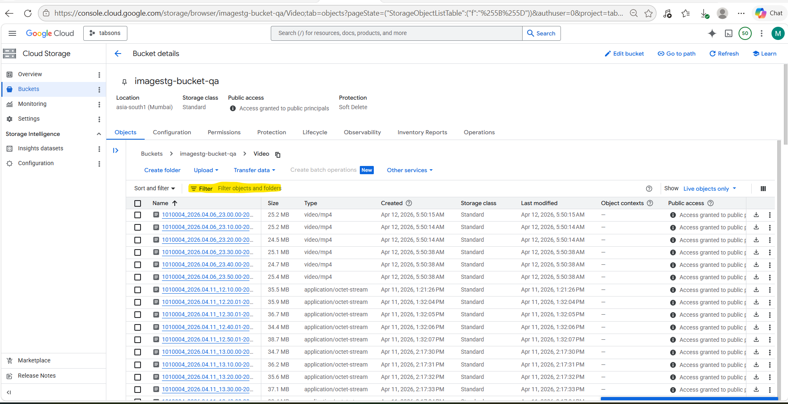
Use the Filter option to search for the required video file.
Path
imagestg-bucket-qa – Bucket details – Cloud Storage – tabsons – Google Cloud console

Outcome
- If the video is present in the bucket:
  - Check the video format, file naming, and playback compatibility.
- If the video is NOT present in the bucket:
  - Proceed to Step 2.

Step 2: Check Video in CDAPI
Login to the Tabsons CDAPI and verify whether the correct video is available there.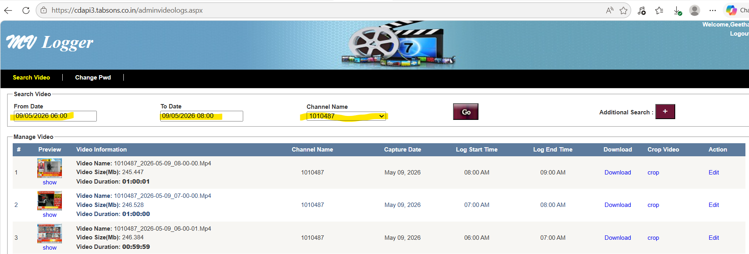

CDAPI Link
Logger

Outcome
- If the correct video is present in CDAPI:
  - Download the video.
- If the correct video is NOT present in CDAPI:
  - Contact Pawan from the Tabsons team and request him to upload the correct video to CDAPI.

Step 3: Place Video in Script Folder
After downloading the video:
- Paste the video into the videos folder of the script.
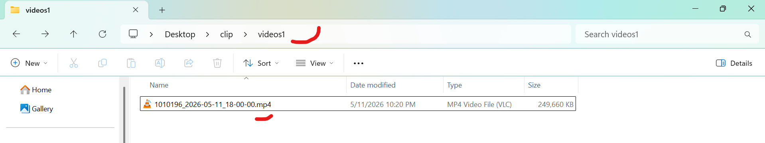
- Rename the file by adding the .mp4 extension at the end of the video name.
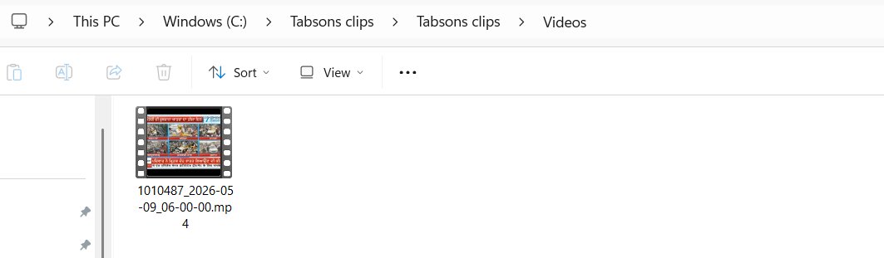

Example
video_name.mp4

Step 4: Run the Script
Open Command Prompt (CMD) in the script directory and run the following command:
python script_name

Step 5: Video Processing
After running the script:
- The videos will automatically be trimmed into 10-minute clips.
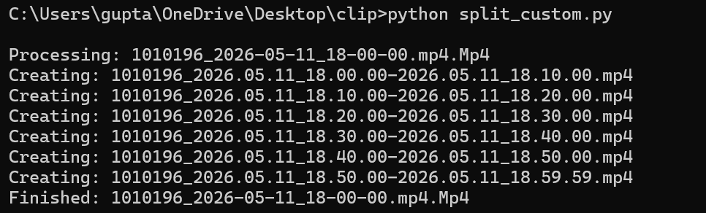
After videos are trimmed upload the missing video into the bucket.
To upload video go into imagestg-bucket-qa: imagestg-bucket-qa – Bucket details – Cloud Storage – tabsons – Google Cloud console then click on upload -> then click on files -> select the required video and upload.
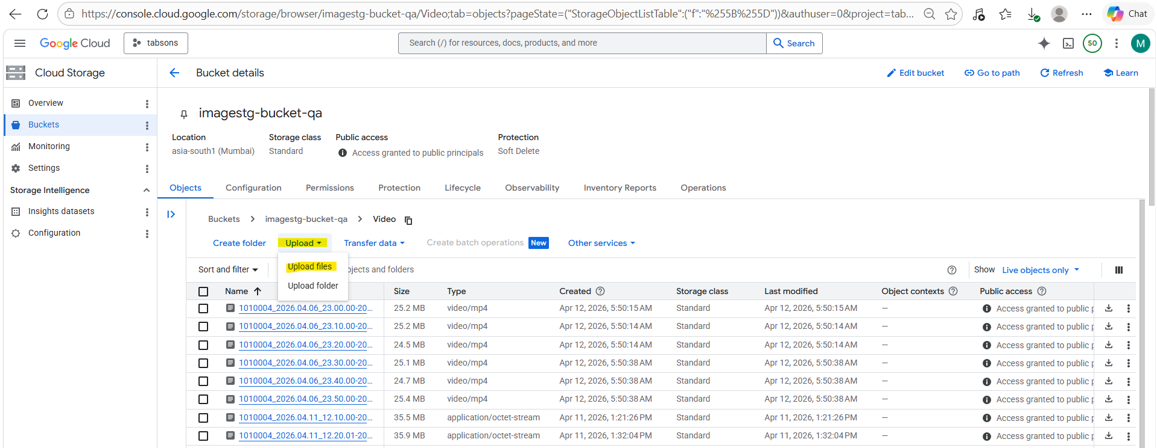
After uploading the video in bucket login into the QA database and check whether video is present in video clipper table or not .
Run following query to check :
Select * from video_clipper where start_time =' enter start time' and channel_code = 'enter channel code';
If the data is already present in the video_clipper table, then we will set the sub_story value for that ID to 0.
UPDATE video_clipper SET sub_story_status = 0 WHERE id IN (869456,869455,869573);
If the video is not present in video clipper table run the following query to insert the video .
INSERT INTO video_clipper (
channel_code,
start_time,
end_time,
mp4url,
sub_story_status
)
VALUES (
enter channel code,
'enter start time',
'enter end time',
‘enter mp4 url’,
enter substory status
);
QA Mysql Database credentials:
IP: 34.180.51.66
Instance: qa-mysql
Instance Password: Dynapt@12345#
DB name: tabsonsdb
user: tabsonsuser

Step 5: Check the frontend data
After the insert or update, we will check the missing data on the frontend after 10–15 minutes and validate it.
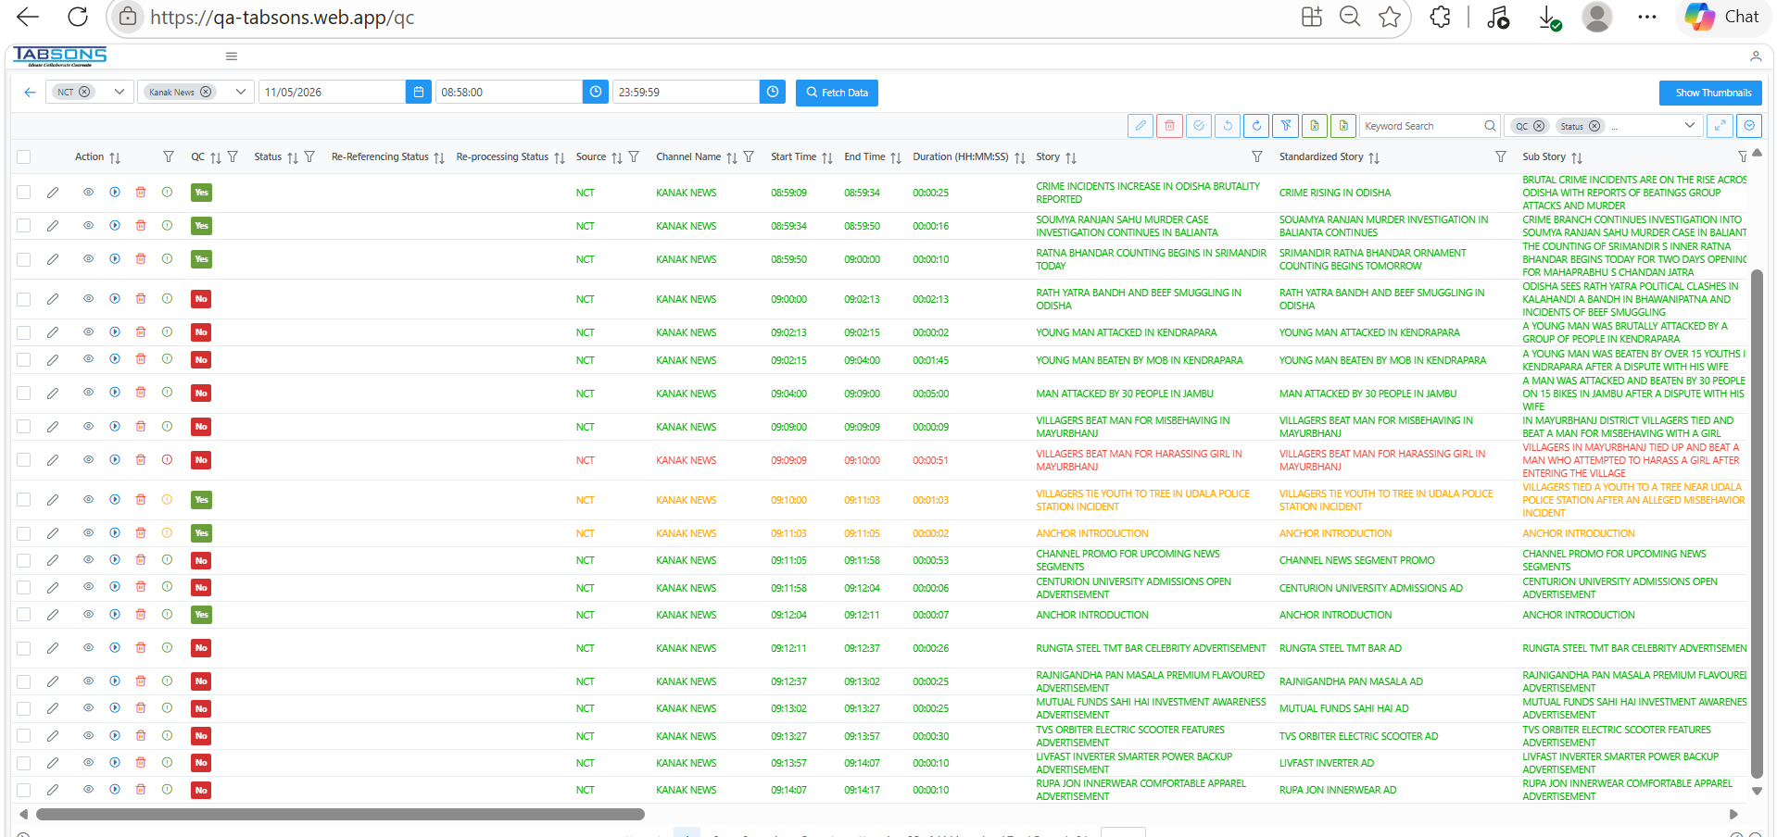

scenario 2 - where video is not present in both video clipper and substory
- Check the frontend and identify the missing substory clip duration. Note the exact start time and end time for which the video is unavailable.
- Delete the affected substory record for the missing duration from the frontend
Ex -
- Download the required video for the missing duration from CDAPI.(follow the CDAPI Download steps)
- Verify that the downloaded video contains the complete content for the missing time range.
- Split the downloaded video into 10-minute clips.(follow the script cut steps)
- Ensure that each clip follows the standard naming convention and format.
- Upload missing duration 10-minute clips to the designated storage bucket.
- Manually insert the corresponding video URL into the Video Clipper table for the affected time range.
EX – The video for 12:50 - 13:00 is missing. We will manually insert an entry into the Video Clipper table by providing the channel name, start time, end time, and video URL. The video URL will be copied from the bucket and inserted into the table.
INSERT INTO video_clipper (
channel_code,
start_time,
end_time,
mp4url,
sub_story_status)

VALUES (
1010268,
'2026-06-16 12:50:00',
'2026-06-16 13:00:00',
'https://storage.googleapis.com/imagestg-bucket-qa/Video/1010268_2026.06.16_12.50.00-2026.06.16_13.00.00.mp4',
0
);
- Validate that the record has been inserted correctly.
- After the Video Clipper entry is created, the inferencing process starts automatically.
- Inferencing and processing typically take 5 to 15 minutes.
- After processing is completed, verify that the data is visible on the frontend.
- Confirm that the missing substory clip is displayed correctly.

scenario 3- where wrong substory is processed in front end and video is not present in bucket.

- Verify the incorrect substory being shown on the frontend.
- DELETE the incorrect substory record from the frontend
- Download the required video for the same time range from CDAPI. - Ensure the video contains the correct content.(follow the CDAPI Download steps)
- Split the downloaded video into 10-minute clips. Ensure that each clip follows the standard naming convention and format.(follow the script cut steps)
- Upload the generated clips to the designated storage bucket. - Verify that the files are uploaded successfully.
- Check whether a Video Clipper record already exists for the same channel and time range. - If the record exists, update the corresponding substory status to 0 for the affected ID.
EX -
UPDATE video_clipper SET sub_story_status = '0'
WHERE id IN (1069205)

- After updating the status to 0, the system will pick the record for reprocessing. - Inferencing will start automatically.
- Processing generally takes 5–15 minutes. - After completion, confirm that the correct substory appears on the frontend.

scenario 4 - where video is showing missing on front end but after opening qc form video is playing in that case video can be reprocessed.
- Identify the substory that is showing as Missing Video on the frontend. Open the corresponding QC form.
- Check whether the video plays successfully in the QC form.
- If the video is playable, no video download or bucket upload is required.
- Select checkbox & click on re-inferencing
Ex -
- Refresh the frontend after processing is completed.
- Confirm that the Missing Video issue has been resolved and the video is displayed correctly.

Thank You

